**Lab Mid**

**Program: BS Software Engineering**

**Department of Computer Science**



**Submitted to: Ma’am Yasmeen**

**Submitted by: Habiba Ashfaq**

**Roll no: SP22-BSE-032**

**Course Title: Advanced Web Technologies**

**COMSATS University Islamabad, Vehari Campus.**

**Project Name: Book Management System**

**Frontend:**

**Add Book:**

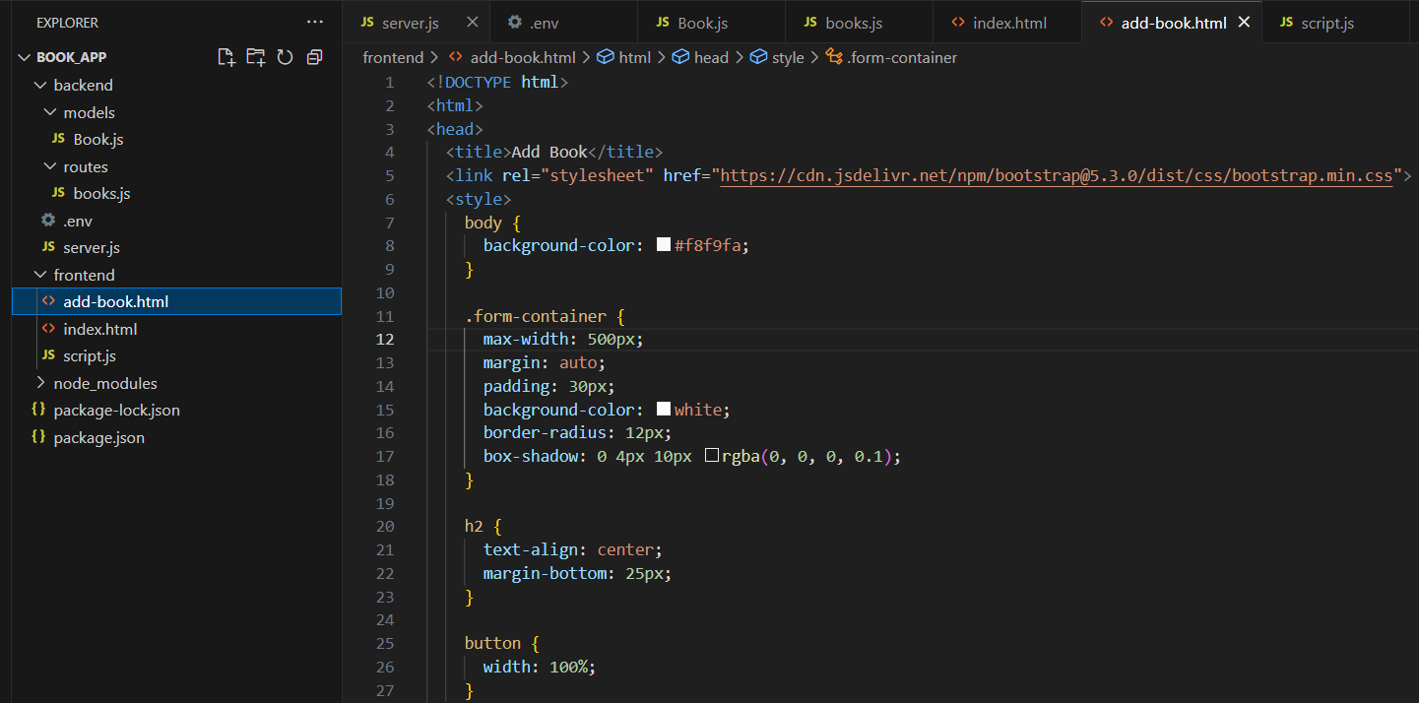

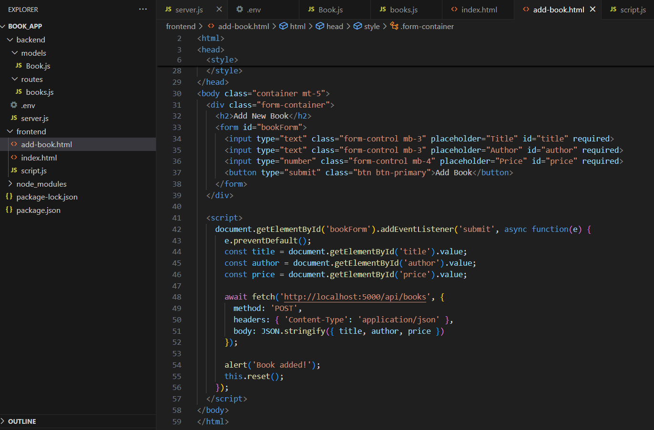

**Index file for Book List:**

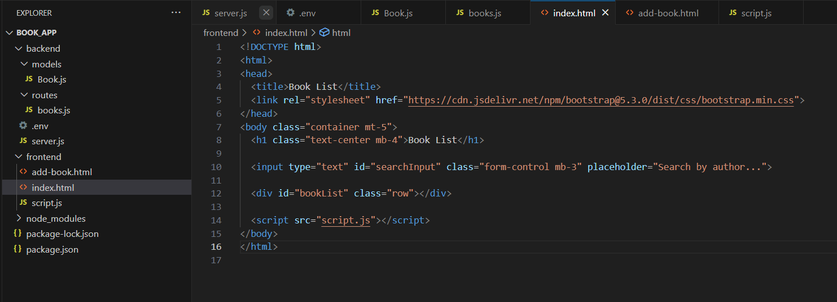

**Script File:**

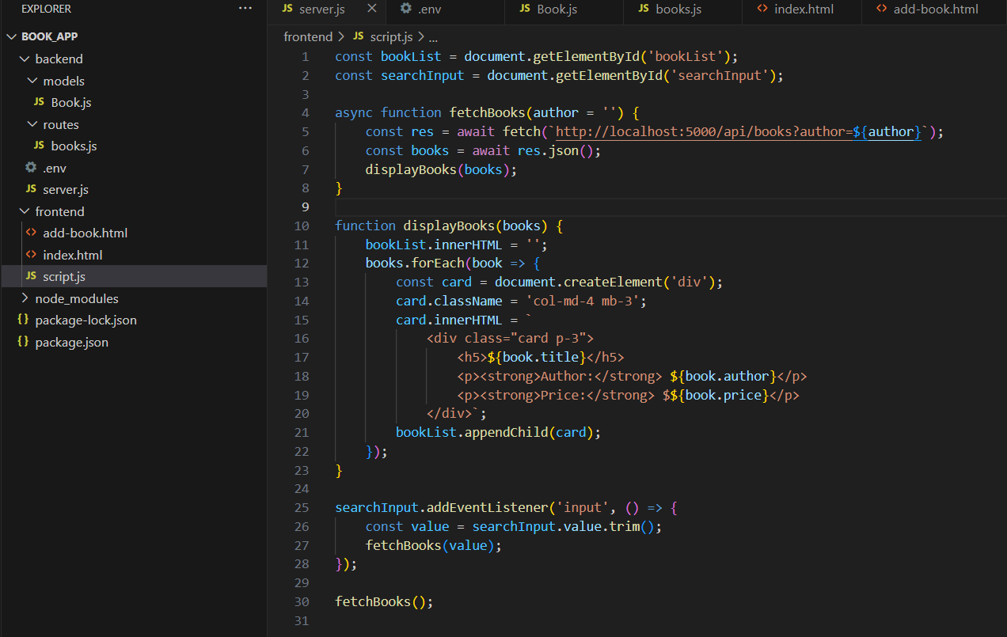

**Backend:**

**.env file:**

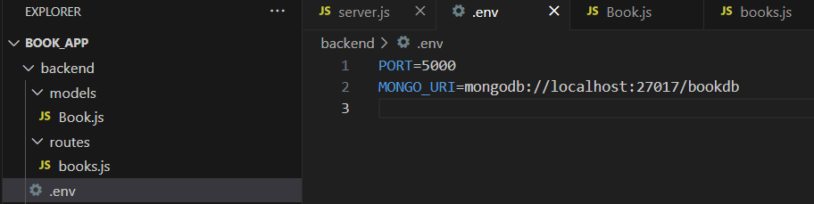

**Server.js file:**

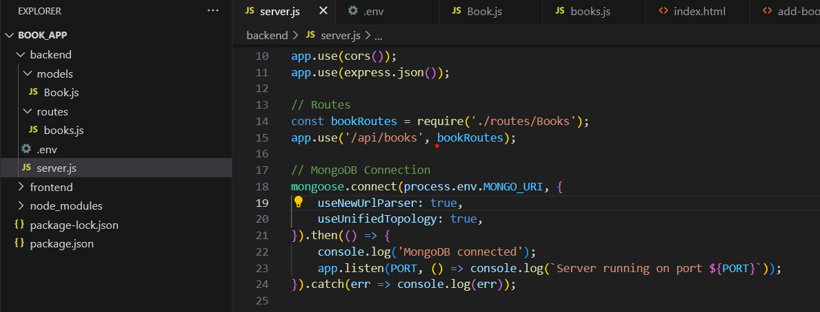

**Routes file:**

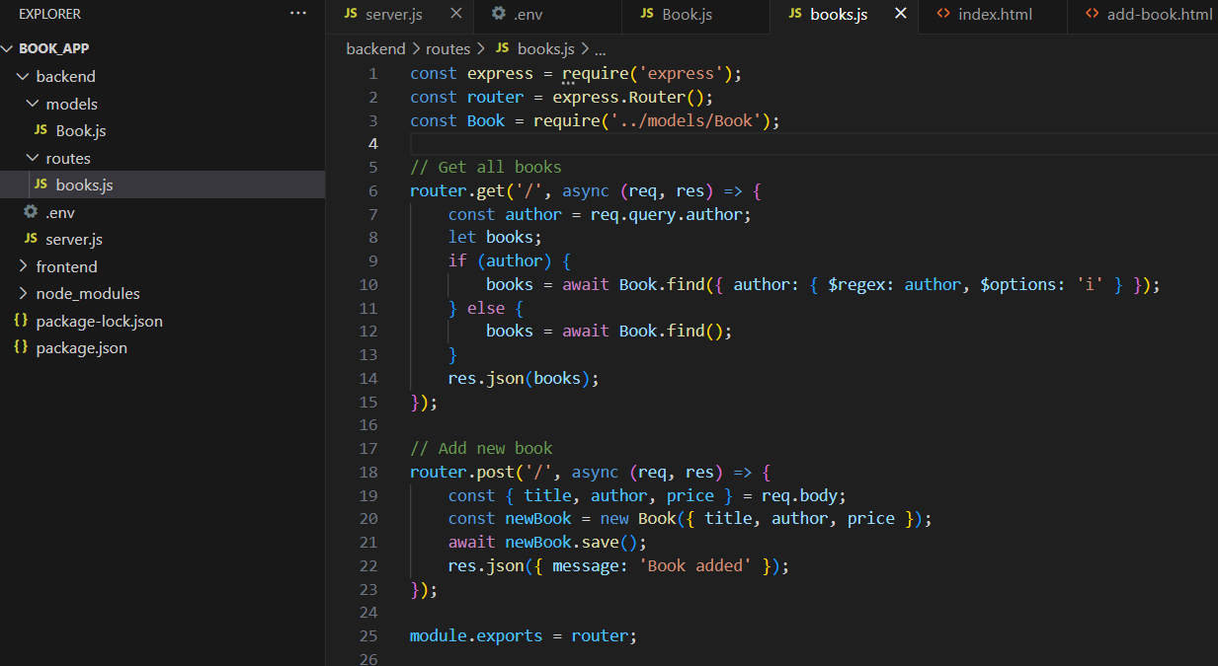

**Models file:**



**Output:**

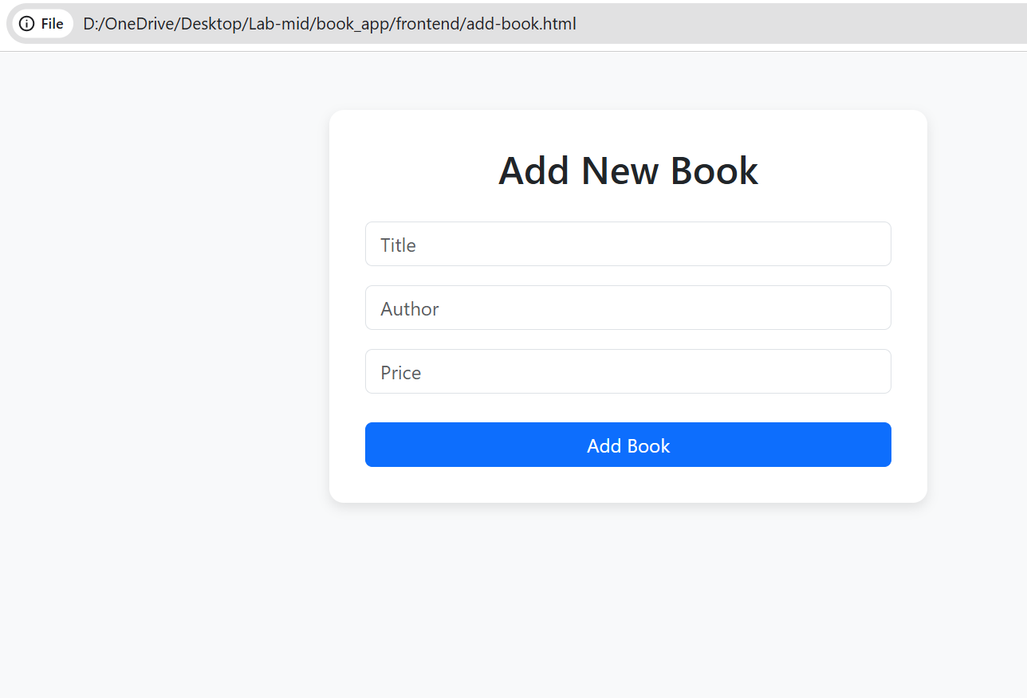

**Book added successfully:**

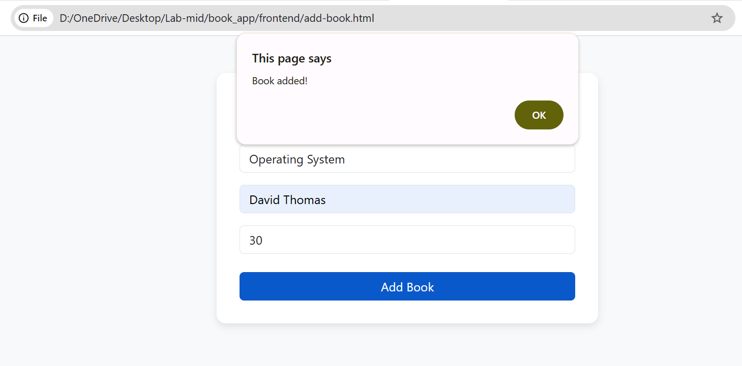

**Book List:**

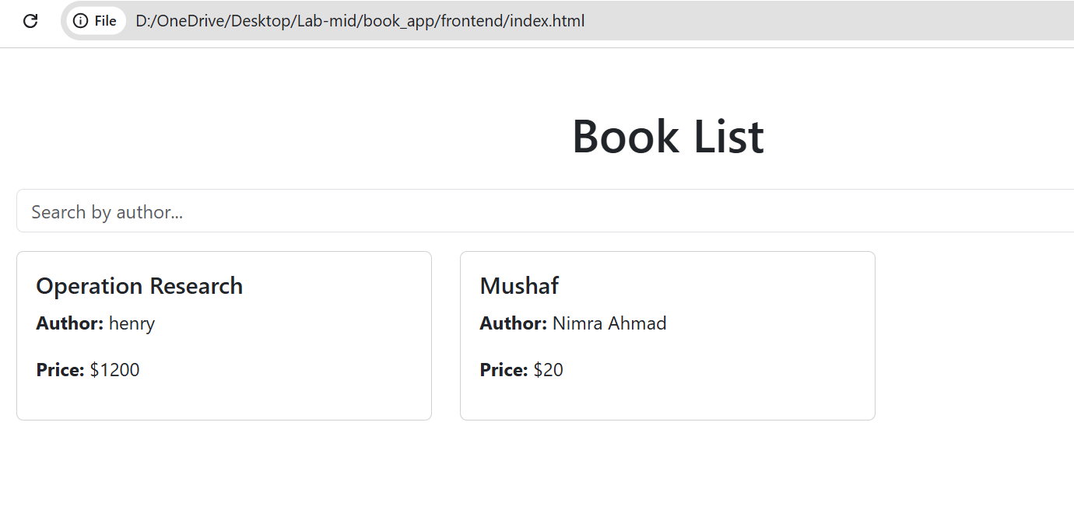

**Methods Output:**

**Get Method:**

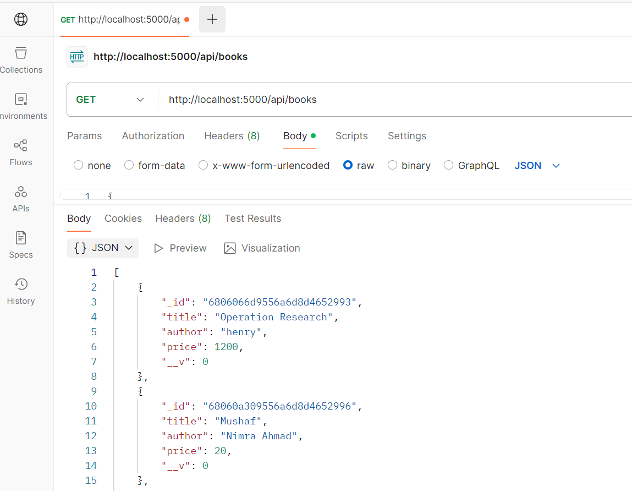

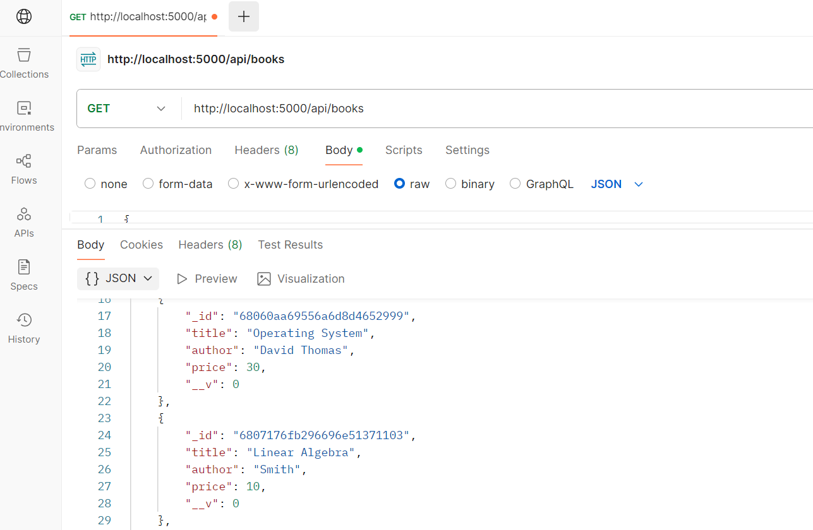

**Post Method:**

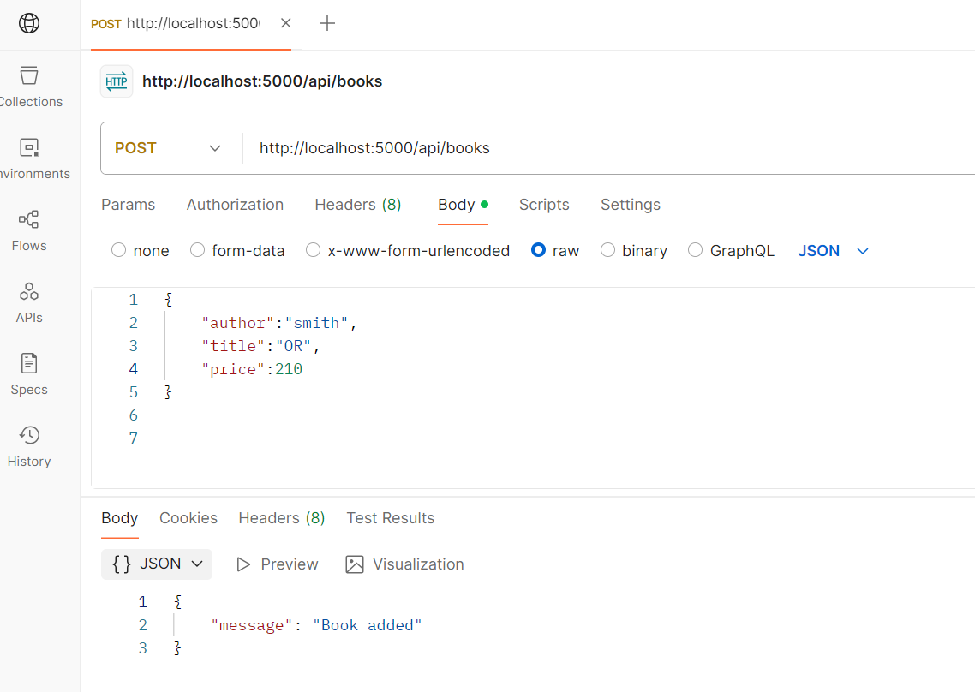

**Mongodb:**

